**Experiment 5**

**Aim:** To design the logical unit of A.L.U.

**Theory:** Arithmetic and Logical Units (or A.L.U.s) are found at the core of the of microprocessors, where they implement the arithmetic and logic functions offered by processor (e.g., addition, subtraction, AND’ing two values, etc.). An A.L.U. is a combinational circuit that combines many common logical circuits in one block. A.L.U. can be designed to perform a variety of different arithmetic and logical functions include AND, OR, XOR, XNOR, INV, CLR (for clear) and PASS (for passing a value unchanged). The data processing part of C.P.U. is responsible for executing arithmetic and logical instructions on various operand types including fixed point and floating-point numbers. Various circuits used to execute data processing instructions are usually combined in a single circuit called an Arithmetic Logic Unit (A.L.U.). The complexity of an A.L.U. is determined by the way in which its arithmetic instructions are realized.

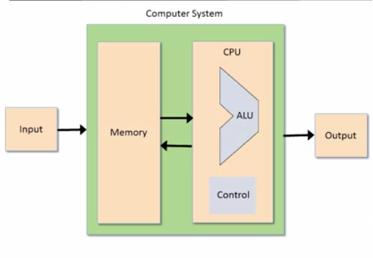

*Fig 1: Structure of A.L.U.*

In the following diagram:

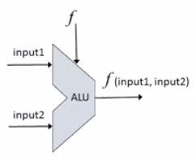

*Fig 2: Representation of A.L.U.*

* The ALU computes the function on two inputs and outputs the result.
* f: one out of the family of the predefined arithmetic and logical functions.

For constructing an A.L.U., one requires three control lines to identify any one of these operations. The input combination of these control lines are shown below:

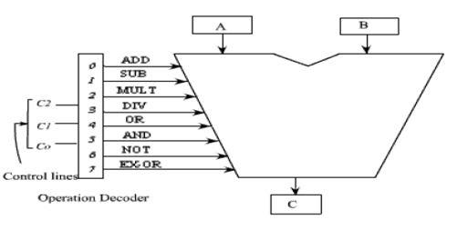

*Fig 3: Block Diagram of A.L.U.*

|  |  |  |  |
| --- | --- | --- | --- |
| C1 | C0 | Arithmetic C2=0 | Logical C2=1 |
| 0 | 0 | Addition | OR |
| 0 | 1 | Subtraction | AND |
| 1 | 0 | Multiplication | NOT |
| 1 | 1 | Division | XOR |

*Table 1: Truth Table for A.L.U.*

In this diagram:

* The control line C2 is used to identify the group logical or arithmetic, i.e.
* C2=0; arithmetic operation C2=1 logical operation.
* Control lines C0 and C1 are used to identify any one of the four operations in a group.

In this experiment we are going to design the logical part of A.L.U. using Multiplexer and Decoder. The truth table of logical part of A.L.U. is as follows:

|  |  |  |
| --- | --- | --- |
| C1 | C0 | Logical Operations |
| 0 | 0 | AND |
| 0 | 1 | OR |
| 1 | 0 | NOT |
| 1 | 1 | XOR |

*Table 2: Truth Table of Logical Unit of A.L.U.*

Here, in this table, control lines C0 and C1 are used to identify any one of the four operations in a group.

**Observations:**

Circuit Representation of Logical Unit of A.L.U. using:

1. Multiplexer:

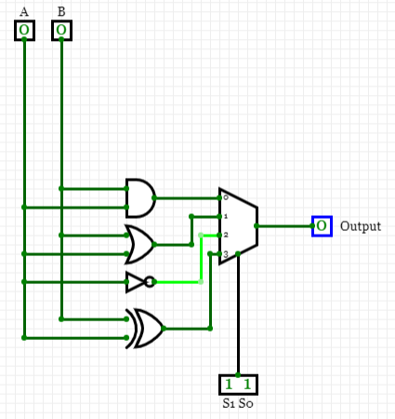

1. Decoder:

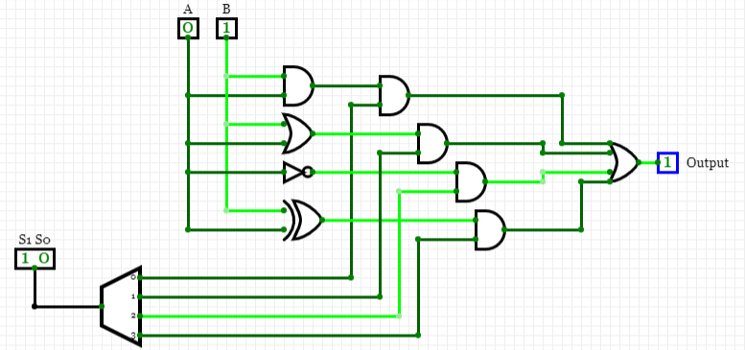

**Result:** The logical unit of A.L.U. has been designed successfully.

|  |  |  |  |
| --- | --- | --- | --- |
| **CRITERIA** | **TOTAL MARKS** | **MARKS OBTAINED** | **COMMENTS** |
| 1. **CONCEPT** | **2** |  |  |
| 1. **IMPLEMENTATION** | **2** |  |  |
| 1. **PERFORMANCE** | **2** |  |  |
| **TOTAL** | **6** |  | |